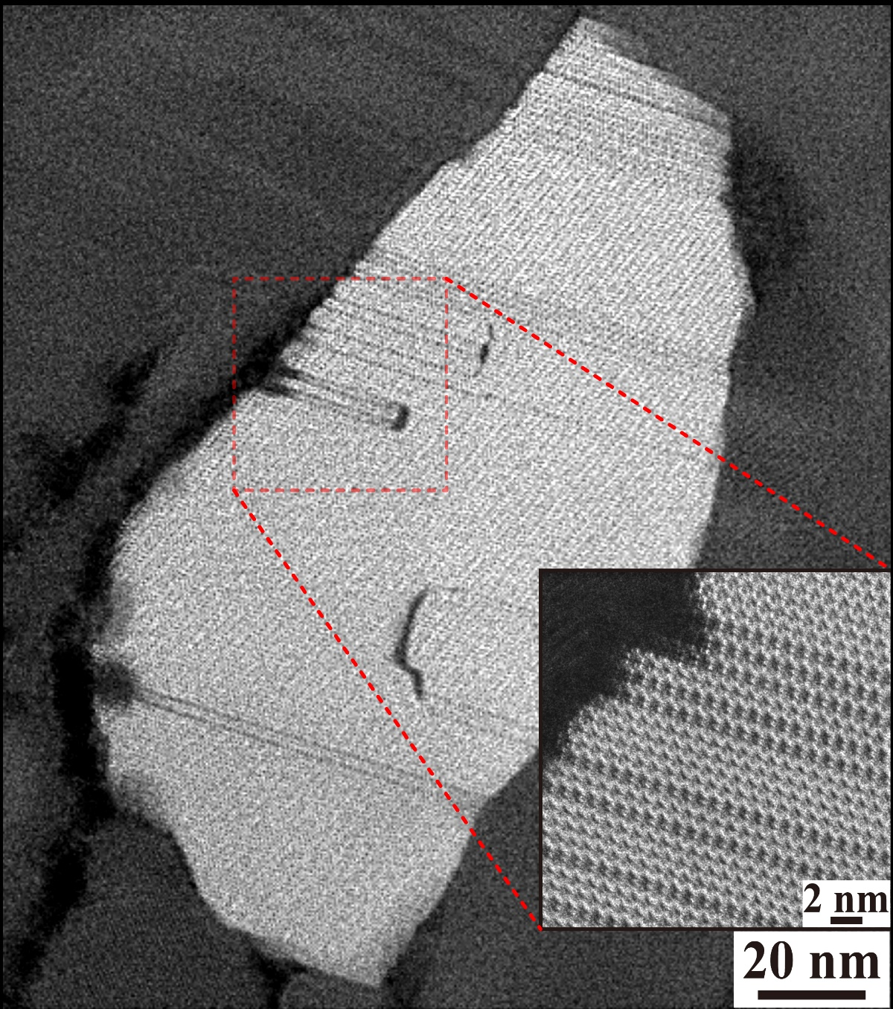
Categories: P3
(Scanning) Transmission electron microscope, (S)TEM.

Name of Photo: How can Help

Illustration: The morphology of the grain of Hetian jade is similar to that of Taiwan. The atomic configurations are composed of a number of stacking faults

Name: Tsai-Fu Chung^{1*}, Jong-Shing Bow², Chien-Nan Hsiao³,
Wei-Chih Li⁴, Jer-Ren Yang¹

University/Organization:
¹Department of Materials Science and Engineering, National Taiwan University, Taipei, Taiwan.
² Integrated Service Technology Inc., Taiwan.
³ National applied research laboratories, Taiwan Instrument Research Institute, Hsinchu, Taiwan.
⁴E.A. Fischione Instruments, Inc., 9003 Corporate Circle, Export, PA 15632, U.S.A.

*Email: f03527003@ntu.edu.tw
Do you authorize the Microscopy Society of Taiwan to use your photograph for publications or webpage contents of the society? Yes No

